THE UNIVERSITY OF AZAD JAMMU & KASHMIR, MUZAFFARABAD


COURSE TITLE | I&CT
COURSE CODE | HU-1104
TITLE | LAB # 11
STUDENT NAME | HASEEB SHEIKH
STUDENT ROLL NUMBER | 2024-SE-31
INSTRUCTOR NAME | ENGR. TAHIR ABBASI
SUBMISSION DATE | MARCH 18, 2025

DEPARTMENT OF SOFTWARE ENGINEERING

Contents

Setting Up a Blogging Account 3
Blog’s Homepage 3
Settings 3
Writing and Publishing a Blog Post 4
Published Blog 4
Adding Multimedia to a Blog Post 4
Formatted Blog with Multimedia 4
Second Half 5
Enabling Comments and Responding to Readers 5
Responding to the comments 5
Customizing Blog Layout and Widgets 6

I&CT
Lab # 11

Setting Up a Blogging Account

Blog’s Homepage
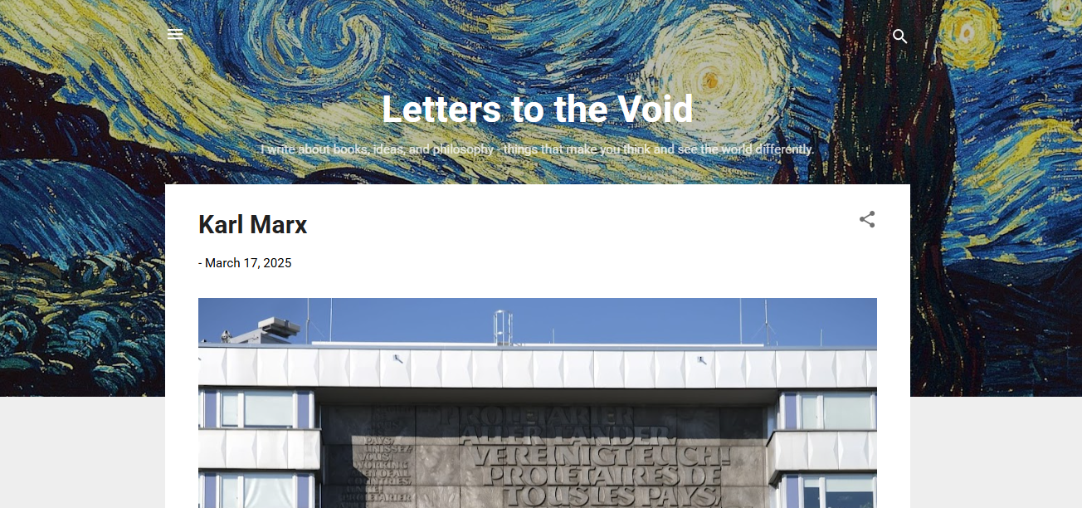

Figure 1: Showing the screenshot of the blog's homepage.

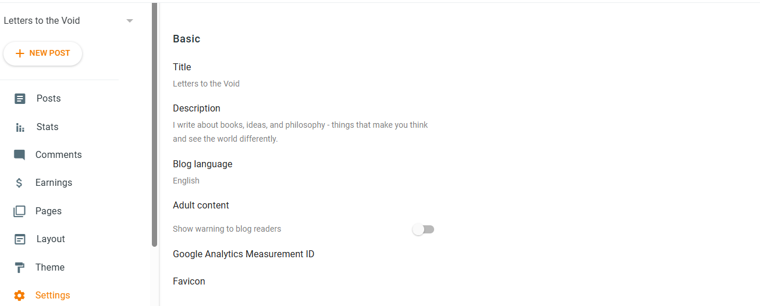
Settings

Figure 2: Showing the screenshot of settings.

Writing and Publishing a Blog Post

Published Blog
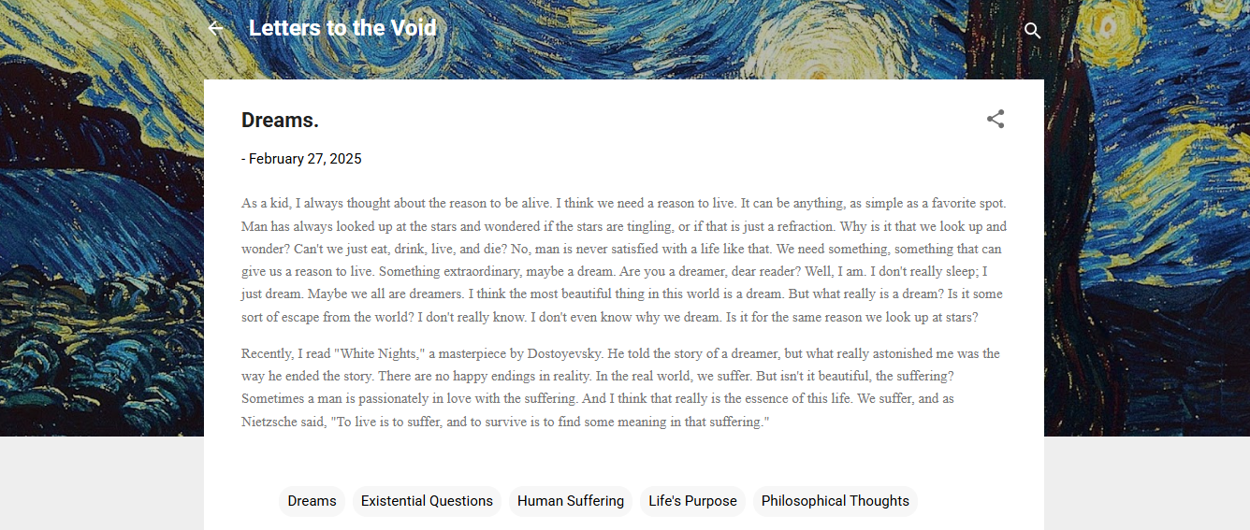

Figure 3: Showing the screenshot of the live post.

Adding Multimedia to a Blog Post

Formatted Blog with Multimedia
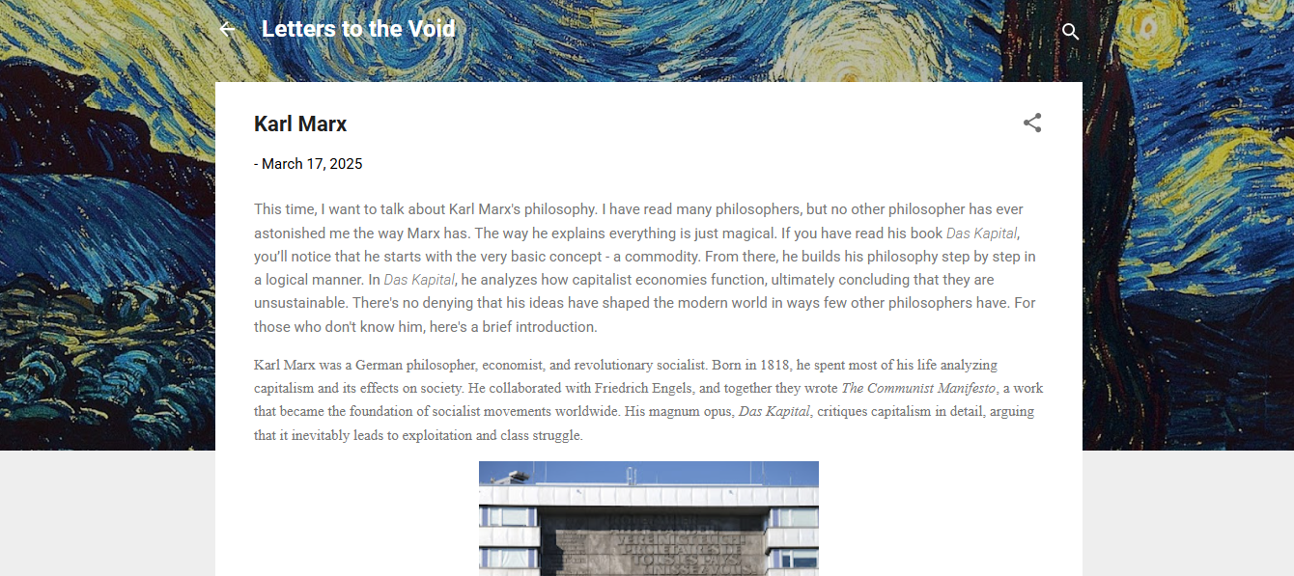

Figure 4: Showing the screenshot of the formatted blog post.

- Formatted blog with proper headings and multimedia.

Second Half
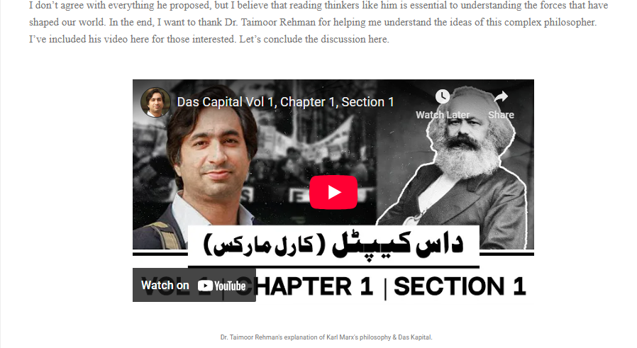
Figure 5: A screenshot of the second half of the formatted blog post.

Enabling Comments and Responding to Readers

Responding to the comments
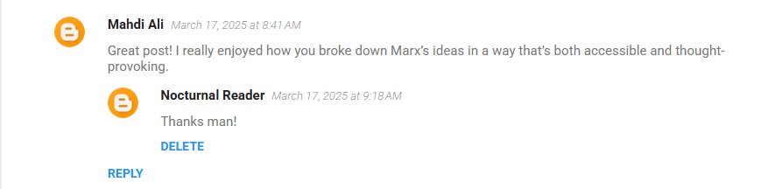
Figure 6: Showing my response to a comment.

Customizing Blog Layout and Widgets
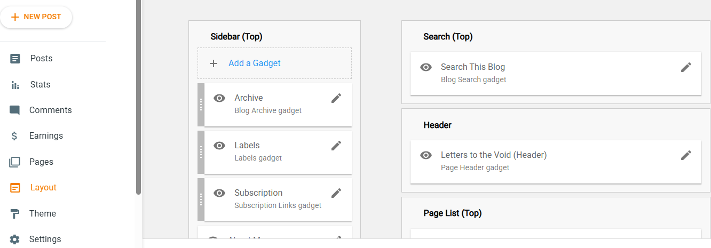
Figure 7: Screenshot showing the customized layout and widgets.

My Learning Experience

I've always wanted to write blogs, but this lab gave me the push to start finally. It helped me learn how to write and customize them in a way that's engaging and easy to read, making my ideas more relatable to the audience.

